https://www.inspiredtaste.net/15938/easy-and-smooth-hummus-recipe/

Key Hummus Ingredients
- Chickpeas (or garbanzo beans) are the base for hummus. The softened beans break down into a smooth paste. You can use canned or home-cooked chickpeas in our recipe. I use them interchangeably, giving home-cooked chickpeas a slight edge regarding flavor. Here’s my method for cooking dried chickpeas.
- Tahini is a paste made from ground sesame seeds, making hummus taste incredible. You can buy tahini, or you can make it yourself. To make hummus that’s 100% from scratch, we use homemade tahini (it’s easy, I promise). Here’s our tahini recipe with a video showing how to make it.
- Fresh lemon juice is essential for great hummus, so skip the bottled juice and buy fresh lemons — 1 large or 2 medium lemons should do.
- Fresh garlic adds a little spice and zest. I add one small clove and find it’s just right. Add more for a garlicky kick, or substitute for more mellow roasted garlic and make roasted garlic hummus. Here’s how we roast garlic.
- Ground cumin and salt help to make it taste amazing, and the ground cumin adds a little more spice and richness.
- Olive oil makes the texture of the hummus luxurious. We also drizzle over the top of the swirly hummus when serving. I like fruity, light-flavored olive oils when making hummus.
In addition to the ingredients above, you can add more flavor to your hummus. I love adding roasted red peppers for red pepper hummus, but olives, pine nuts, roasted garlic, and extra spices are also great options. You can also add ingredients to the top of hummus, like in this spiced beef and feta hummus.

How to Make Hummus from Scratch
The secret to the best hummus is the order in which you add ingredients to your food processor. Seriously, it’s that easy. Tahini and lemon juice go in first. Then, before you add anything else, turn on the food processor and let it run for a minute or two.
See the photos below? I’m pouring tahini into a clean food processor in the first photo. After a minute of being whirled, whipped, and creamed in the food processor, it turns into the paste you see in the following image. It’s lighter in color and much thicker.
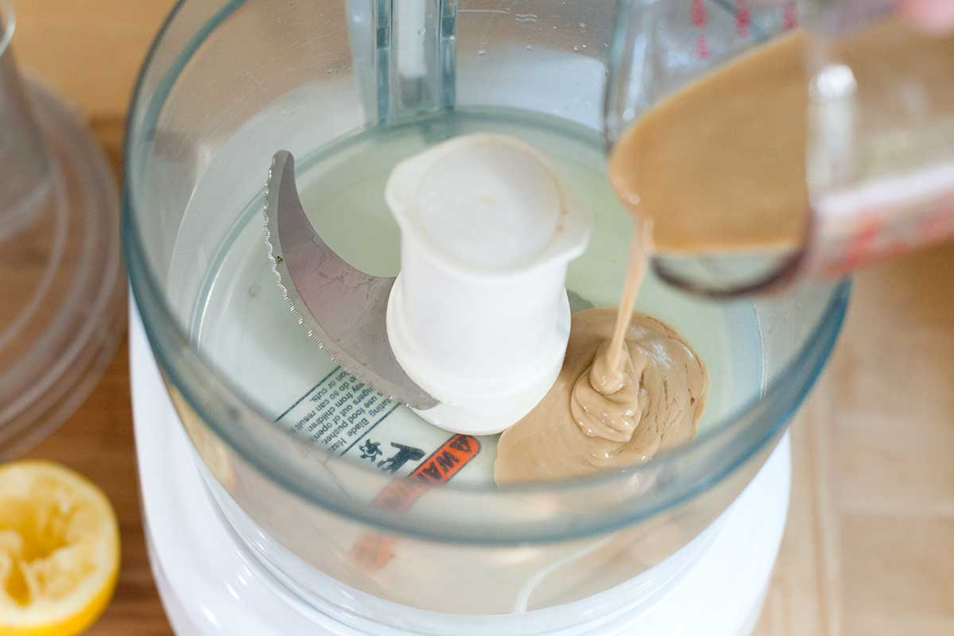
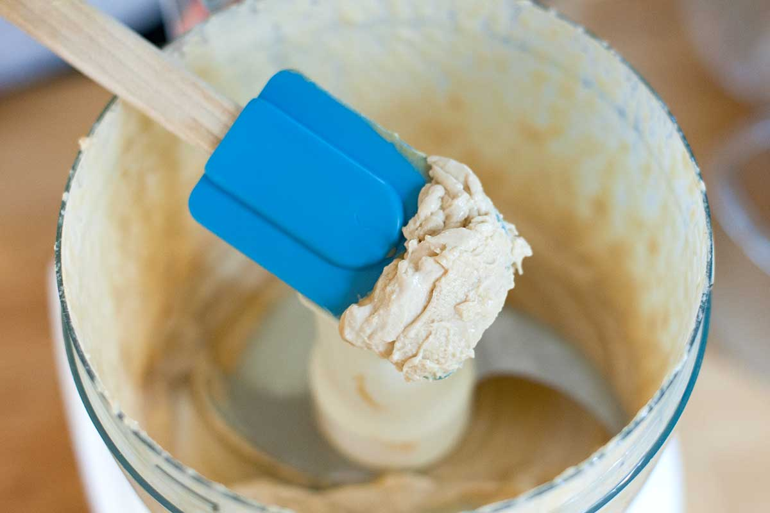
Now, we can add the remaining hummus ingredients, but make sure you stand back and let that food processor run. I also like adding the chickpeas in two batches, processing the first batch for a minute before following up with the rest.
Cold water or aquafaba is our last trick for fluffy, creamy, whipped hummus. After all the ingredients are added and processed into a smooth paste, I love to drizzle in some extra liquid with the processor still running. The liquid (and extra process time) turns the smooth mixture into a fluffy, luxurious dip! I use cold water in our video, but aquafaba (the liquid from cooking or canned chickpeas) works, too.

