THE BEST CLASSIC SHEPHERD’S PIE
February 9, 2019
PINTERESTFACEBOOKEMAIL
Jump to Recipe Jump to Video Print Recipe
The Best Classic Shepherd’s Pie – AKA Shepards Pie or Cottage Pie. Ground Beef (or lamb) with vegetables in a rich gravy, topped with cheesy mashed potatoes, and baked.
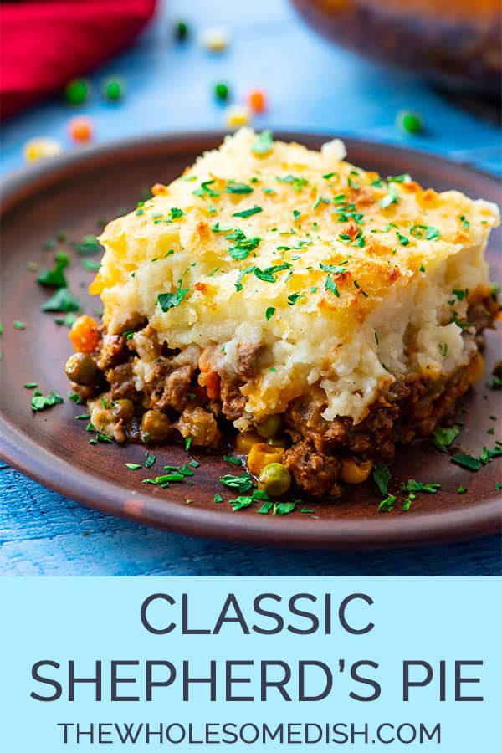

SHEPHERD’S PIE
So, this is how you spell it: Shepherd’s Pie. But, from doing a quick google search, it came to my attention that TONS of people think it’s Shepards Pie.

IRISH SHEPHERD’S PIE
Traditional Irish Shepherd’s Pie would actually call for ground lamb. The difference between Shepherd’s Pie and Cottage Pie is the meat. Cottage Pie uses ground beef, while Shepherd’s Pie uses ground lamb.
I called this recipe Shepherd’s Pie. But, I wrote the recipe so that you could use ground beef or ground lamb.
I typically use ground beef because it is widely available. But, for a special occasion, like St. Patricks day, I would use ground lamb.

HOW TO MAKE SHEPHERD’S PIE
(Note – The full printable recipe is at the bottom of this post)
- Sauté some chopped onions in olive oil.
- Add ground beef or ground lamb.
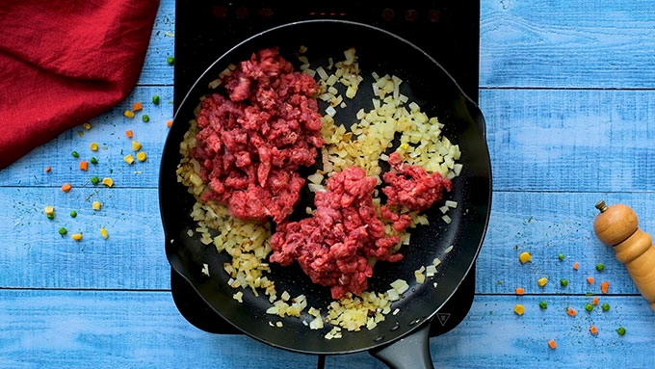
- Add dried parsley, dried thyme, dried rosemary, salt, and pepper.
- Stir and cook the meat mixture until the meat is browned.
- Add minced garlic and Worcestershire sauce.
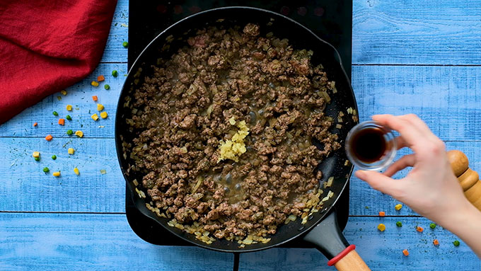
- Cook the garlic for a minute.
- Add flour and tomato paste.
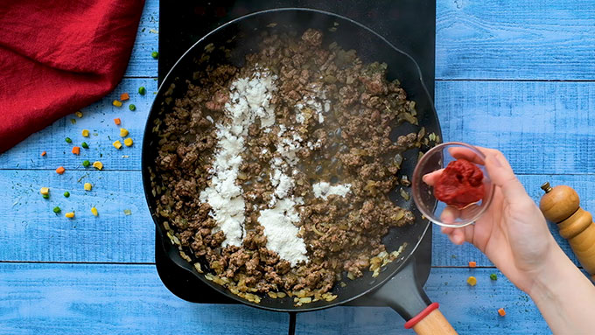
- Add beef broth, frozen mixed peas and carrots, and frozen corn kernels.
- Simmer the meat gravy until it is thick.
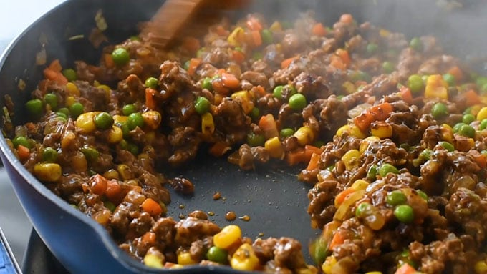
- Boil some peeled and chopped potatoes until they are soft.
- Drain the potatoes
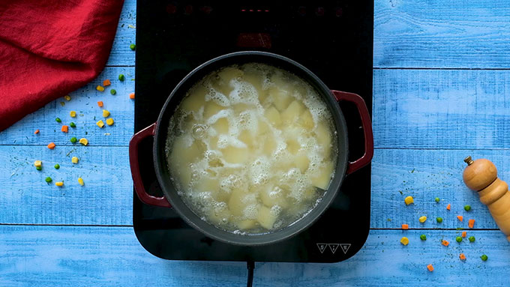
- Add butter, half & half, parmesan cheese, garlic powder, salt, and pepper.
- Mash the potatoes until smooth.
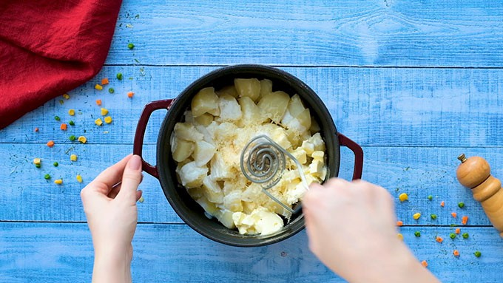
- Pour the meat mixture into a casserole dish.
- Top it with the cheesy mashed potatoes.
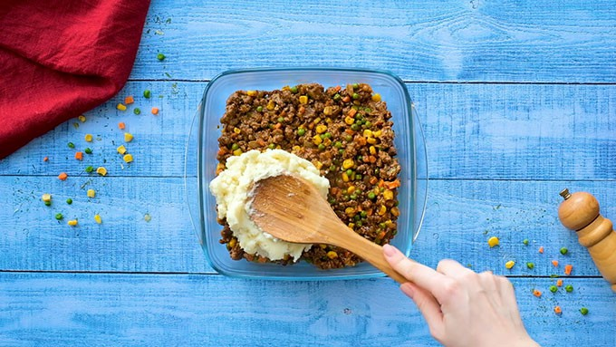
- Bake until the meat is bubbling and the potatoes are golden.
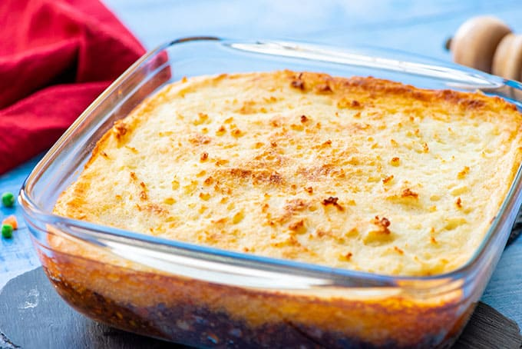

EASY SHEPHERD’S PIE
Making the best Shepherd’s Pie is not difficult. But, there are a few steps to it. You have to make the meat mixture, the mashed potatoes, assemble the casserole, and bake it.
I find that the easiest way to make this dish is to work ahead. You could make the beef or lamb mixture ahead of time. Or, you could make the mashed potatoes ahead of time.
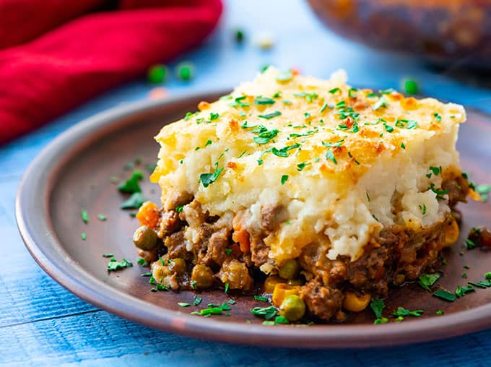
You could also make the whole recipe ahead of time. Just assemble the casserole, cover the dish, and keep it in the refrigerator until you are ready to bake it. I find it is best to bake it within 3 days of preparing it.
When you are ready to bake it, take it out of the refrigerator for about 20 minutes before you need to bake it to let it start coming to room temperature. Uncover it, and bake.

WHAT TO SERVE WITH THE BEST SHEPHERD’S PIE
- Deviled Eggs
- Roasted Broccoli from Skinnytaste
- The Best Chocolate Chip Cookies

WATCH THE VIDEO FOR THE BEST CLASSIC SHEPHERD’S PIE BELOW.


Best Classic Shepherd’s Pie Recipe
The Best Classic Shepherd's Pie - AKA Shepards Pie or Cottage Pie. Ground Beef (or lamb) with vegetables in a rich gravy, topped with cheesy mashed potatoes and baked.
Prep Time20 minutes
Cook Time50 minutes
Total Time1 hour 10 minutes
Shepherd's Pie Recipe
Volume 0%
00:25
01:00
More Videos
01:00
The Best Classic Meatloaf Recipe
00:54
Best Classic Chicken Pot Pie Recipe
01:00
The Best Classic Chili Recipe
00:58
The Best Classic Zucchini Bread Recipe
01:00
The Best Classic Lasagna Recipe
00:58
The Best Classic Hamburger Recipe
Close

Servings: 6 servings

Calories: 400kcal

Author: Amanda Finks
Print Recipe Pin Recipe Rate this Recipe
4.99 from 202 votes

Ingredients

Meat Filling:
- 2 tablespoons olive oil
- 1 cup chopped yellow onion
- 1 lb. 90% lean ground beef -or ground lamb
- 2 teaspoons dried parsley leaves
- 1 teaspoon dried rosemary leaves
- 1 teaspoon dried thyme leaves
- 1/2 teaspoon salt
- 1/2 teaspoon ground black pepper
- 1 tablespoon Worcestershire sauce
- 2 garlic cloves -minced
- 2 tablespoons all purpose flour
- 2 tablespoons tomato paste
- 1 cup beef broth
- 1 cup frozen mixed peas & carrots*
- 1/2 cup frozen corn kernels

Potato Topping:
- 1 1/2 - 2 lb. russet potatoes -about 2 large potatoes peeled and cut into 1 inch cubes
- 8 tablespoons unsalted butter -1 stick
- 1/3 cup half & half
- 1/2 teaspoon garlic powder
- 1/2 teaspoon salt
- 1/4 teaspoon ground black pepper
- 1/4 cup parmesan cheese

Instructions

Make the Meat Filling.
- Add the oil to a large skillet and place it over medium-high heat for 2 minutes. Add the onions. Cook 5 minutes, stirring occasionally.
- Add the ground beef (or ground lamb) to the skillet and break it apart with a wooden spoon. Add the parsley, rosemary, thyme, salt, and and pepper. Stir well. Cook for 6-8 minutes, until the meat is browned, stirring occasionally.
- Add the Worcestershire sauce and garlic. Stir to combine. Cook for 1 minute.
- Add the flour and tomato paste. Stir until well incorporated and no clumps of tomato paste remain.
- Add the broth, frozen peas and carrots, and frozen corn. Bring the liquid to a boil then reduce to simmer. Simmer for 5 minutes, stirring occasionally.
- Set the meat mixture aside. Preheat oven to 400 degrees F.

Make the potato topping.
- Place the potatoes in a large pot. Cover the potatoes with water. Bring the water to a boil. Reduce to a simmer. Cook until potatoes are fork tender, 10-15 minutes.
- Drain the potatoes in a colander. Return the potatoes to the hot pot. Let the potatoes rest in the hot pot for 1 minute to evaporate any remaining liquid.
- Add butter, half & half, garlic powder, salt, and pepper. Mash the potatoes and stir until all the ingredients are mixed together.
- Add the parmesan cheese to the potatoes. Stir until well combined.

Assemble the casserole.
- Pour the meat mixture into a 9x9 (or 7x11) inch baking dish. Spread it out into an even layer. Spoon the mashed potatoes on top of the meat. Carefully spread into an even layer.
- If the baking dish looks very full, place it on a rimmed baking sheet so that the filling doesn’t bubble over into your oven. Bake uncovered for 25-30 minutes. Cool for 15 minutes before serving.

Notes
*If you can’t find frozen mixed peas and carrots, you could use 1/2 cup frozen peas and 1/2 cup frozen sliced carrots.

Nutrition
Serving: 1/6th of the recipe | Calories: 400kcal | Carbohydrates: 13g | Protein: 19g | Fat: 30g | Saturated Fat: 15g | Cholesterol: 97mg | Sodium: 751mg | Potassium: 483mg | Fiber: 2g | Sugar: 2g | Vitamin A: 2860IU | Vitamin C: 7.9mg | Calcium: 99mg | Iron: 2.7mg
Course Dinner, Entree, Main Course
Cuisine American, Irish
Keyword Classic shepherd's pie, How to make shepherd's pie, Shepherd's Pie Recipe
Pin This Recipe

