Chinese Noodle Soup
BY:Nagi
PUBLISHED:27 May '20UPDATED:21 Sep '21

- https://www.recipetineats.com/chinese-noodle-soup/

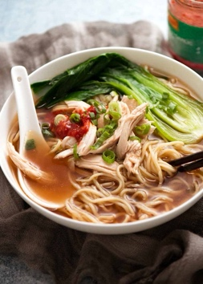

Fast Chinese Noodle Soup!
This Chinese Noodle Soup is one of my classic “back pocket” recipes because it’s so versatile and incredibly quick. Because people who cook all day for a living need quick dinners for real life – ask any chef!!
Here’s a run down of how it goes:
- Broth: Plonk and simmer 6 ingredients for 10 minutes (no trip to the Asian store required!);
- Noodles: Prepare fresh OR dried noodles according to packet directions;
- Toppings: Rummage in fridge and locate vegetables & proteins of choice. Chop roughly and cook with the noodles or in the soup. broth; and
- Serve: Place noodles in bowls. Pour over soup and toppings.
See? 10 minutes!
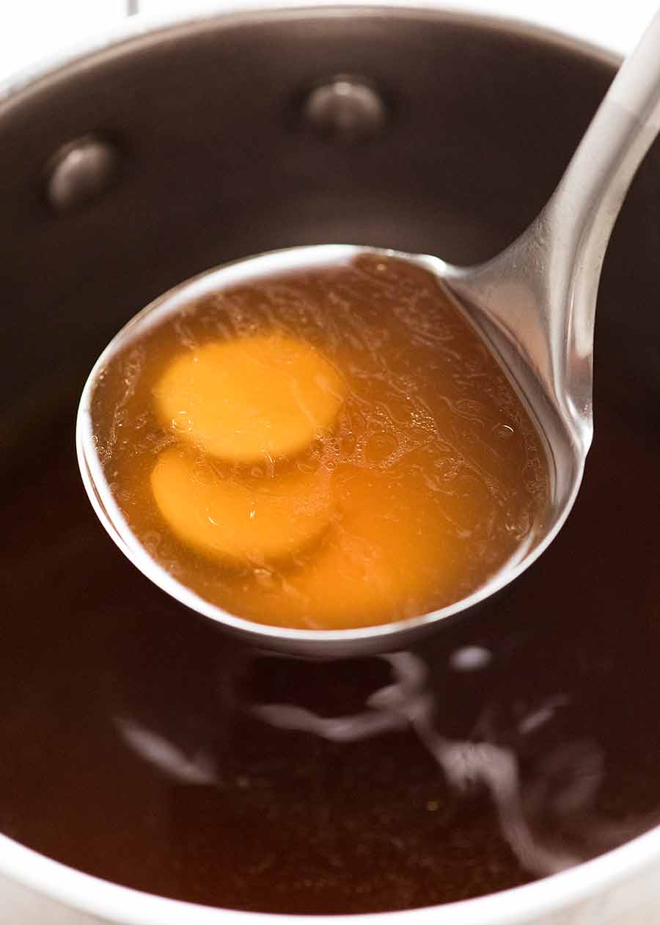

Seasonings for Chinese soup broths
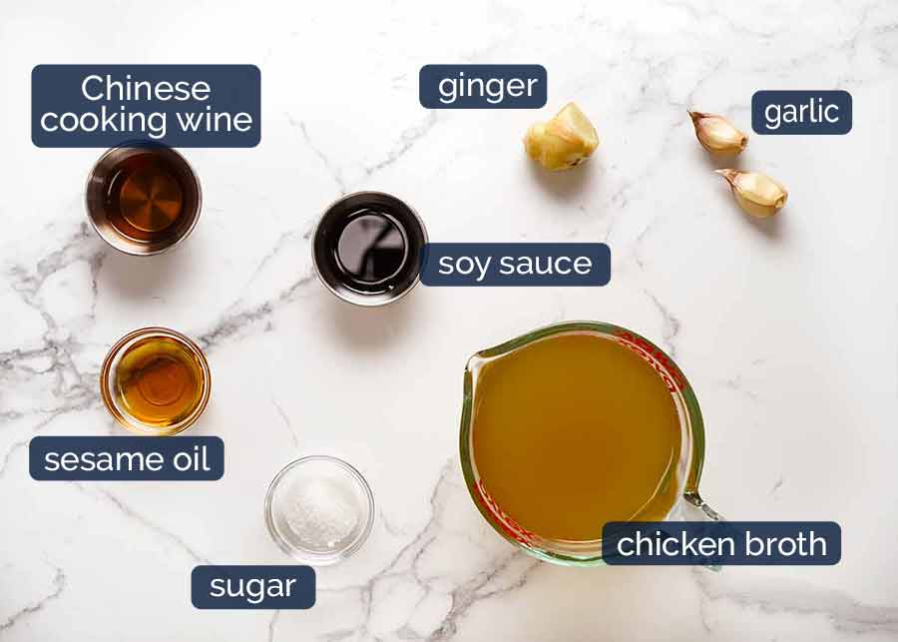
- Chinese cooking wine – the key ingredient. Just 1.5 tablespoons adds complexity and depth of flavour to the store bought chicken stock. Without it, the broth will taste “flat” ie missing something. Substitute with: dry sherry, mirin or cooking sake. Best non alcoholic sub for this recipe: substituting some of the soy sauce with oyster sauce (which adds extra “umami” into the broth to compensate);
- Garlic and ginger – smash the garlic and slice the ginger to allow the fresh flavours to infuse into the broth. Keeping them whole makes it easy to pick out later – you could very well grate them straight into the broth using a fine grater, but you will get little bits in the soup (rather than being a clear broth);
- Sesame oil – for the flavour!
- Chicken broth/stock –
- Soy sauce – either all purpose or light soy sauce will work here.
- Sugar – just a touch, to balance out the flavours.

What goes in the noodle soup
And here’s what I put in the soup:
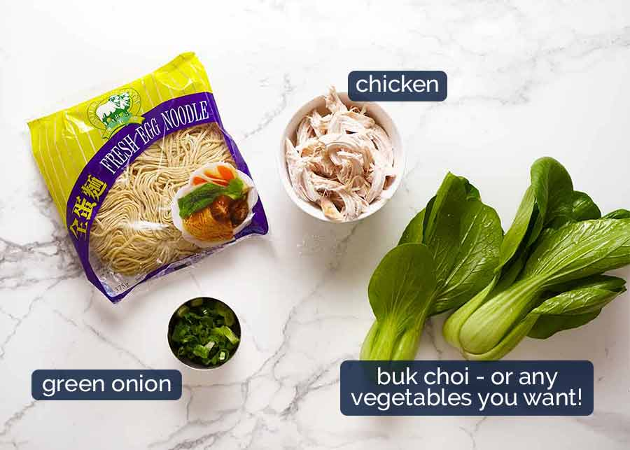
- Noodles – Chinese noodle soups are traditionally made with thin egg noodles (pictured above, and below in the soup). Fresh ones (sold in the fridge section) have a better texture than dried. But any noodles will be fine here – fresh or dried, rice noodles, white or yellow noodles, Hokkien, Singapore noodles, wide, thin, vermicelli, ramen noodles (yup!), diet noodles (like konyaku – been there, done that), zoodles (been there too). Really. ANY noodles will be great in this broth!
- Bok Choy (also known as buk choi, buk choi, pak choi, or pok choi – crazy right??!) – or any vegetables. I like bok choy because you just split them in half down the middle and bam! You’re done! (Recipe notes includes an extensive list of chopping and cook directions for common vegetables)
- Cooked Chicken (poach it using this method that guarantees juiciness)- or any other protein, as desired. Everybody keeps little containers of cooked shredded chicken in the freezer, right?!
- Green onion or coriander/cilantro, or chives, or even finely sliced onion (red, white, yellow brown) – something for a little hit of freshness.

- Don’t use dark soy sauce or sweet soy sauce – the flavour of these are too intense; and

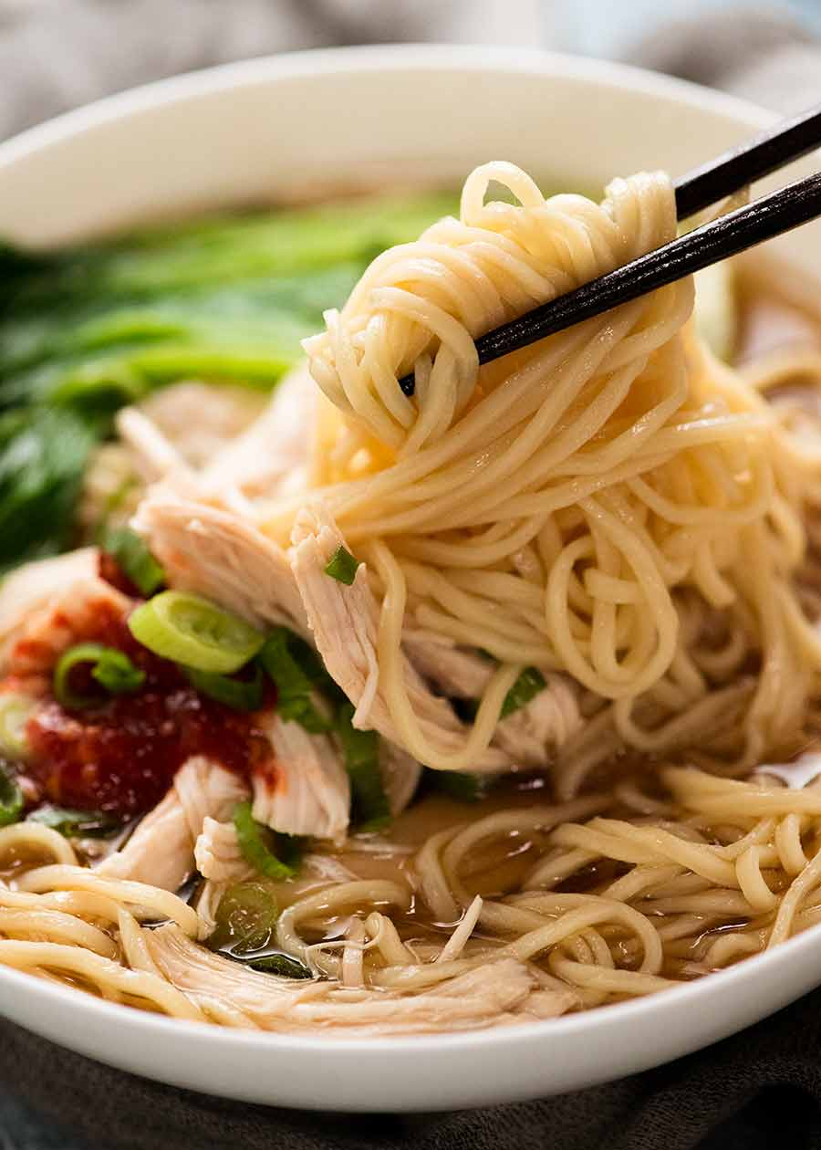

How to make Chinese Noodle Soup
And here’s how it happens in 10 minutes. (And to all those cheeky buggers who will point out that if you have to simmer for 10 minutes, then it takes longer than 10 minutes – fine! You can take a 2 minutes off the simmer time!)
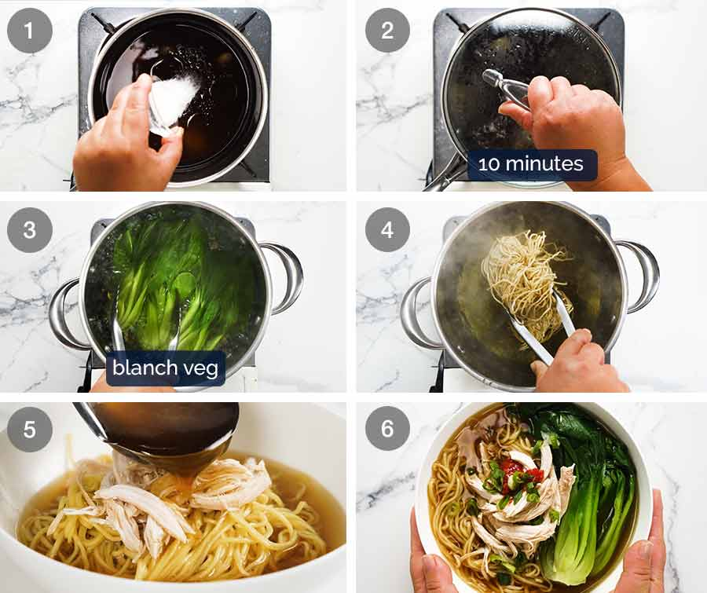
PRO TIP: Never cook noodles in the soup broth unless a recipe specifically calls for it. Noodles suck up loads of liquid when they cook, so if you do that you’ll end up with way less broth than you expect. Learnt this the hard way.
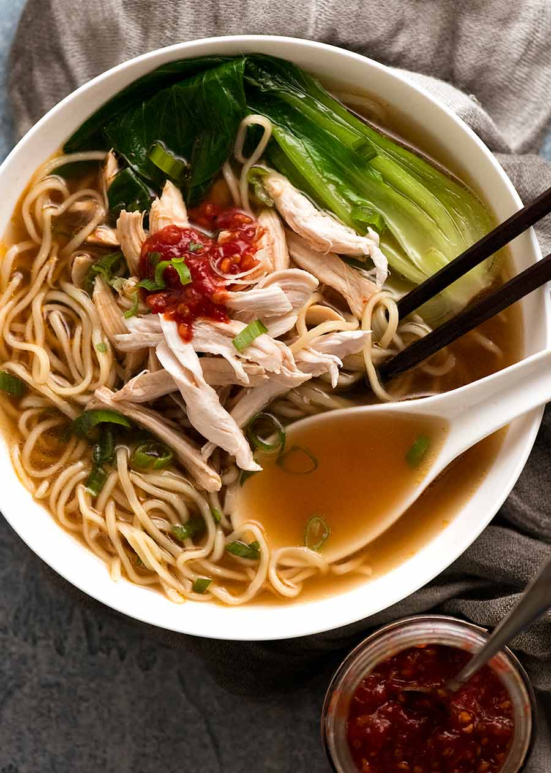

Make it even HEALTHIER!!
Being that this is a noodle soup recipe and all, noodles are a key ingredient here. Even so, it clocks in at just 352 calories for a bowl.
But if you want to cut down on the carbs and calories even further, just skip the noodles and load it up with tons more vegetables to make a Chinese vegetable soup. In fact, it’s one of my “go-to” diet dinners (which should happen more frequently than it does…).
Do I miss the noodles? Of course I do. But I console myself with a healthy dose of chilli paste and lots of fresh herbs, Chicken Pho style.
But before you make it diet, try it the way it’s intended. THEN healthify it!!! – Nagi x

Watch How To Make It
HUNGRY FOR MORE? Subscribe to my newsletter and follow along on Facebook, Pinterest and Instagram for all of the latest updates.
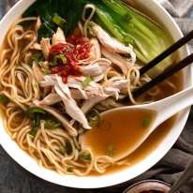

Chinese Noodle Soup
Author:Nagi | RecipeTin Eats

Prep: 5 mins

Cook: 10 mins

Total: 15 mins

Soup

Asian, Chinese
4.98 from 110 votes
Servings2

Tap or hover to scale
Print

Recipe video above. A simple, delicious Chinese noodle soup with a broth that you'd swear came from your favourite Chinese restaurant! This is a midweek version so it's made with store bought soup broth rather than a made from scratch broth. I've kept the toppings very simple because this recipe is more about the broth than the toppings. You can add any toppings you want - vegetables and proteins (refer Note 7).

Ingredients
CupsMetric

BROTH
- ▢3 cups chicken stock/broth, low sodium (Note 1)
- ▢2 garlic cloves , smashed (Note 2)
- ▢1.5 cm / 1/2" ginger piece, cut into 3 slices (optional, but highly recommended)
- ▢1 1/2 tbsp light soy sauce , or normal all purpose soy sauce (Note 3)
- ▢2 tsp sugar (any)
- ▢1 1/2 tbsp chinese cooking wine (Note 4)
- ▢1/4 - 1/2 tsp sesame oil , toasted (optional) (Note 5)

TOPPINGS & NOODLES
- ▢180g / 6oz fresh egg noodles (Note 6)
- ▢2 large bok choy or other vegetables of choice (use any blanchable veg - Note 7)
- ▢1 cup shredded cooked chicken (or other protein of choice)
- ▢1 scallion / shallot , green part only finely sliced (optional garnish)

Instructions

- Place Broth ingredients in a saucepan over high heat. Place lid on, bring to simmer then reduce to medium and simmer for 8 - 10 minutes to allow the flavours to infuse.
- Meanwhile, cook noodles according to packet directions.
- Cut bok choys in half (for small / medium) or quarter (for large). Wash thoroughly.
- Either cook the bok choi in the broth in the soup broth OR noodle cooking water for 1 min (if noodles required boiling).
- Pick garlic and ginger out of soup.
- Place noodles in bowls. Top with chicken and bok choy. Ladle over soup, garnish with green onions. Great served with chilli paste or fresh chillis.

Recipe Notes:
1. Chicken stock/broth - just store bought chicken broth is fine here, but get a good quality one (Campbells in Australia is my favourite brand). Don't use chicken stock powder with hot water for this recipe - the flavour is too chickeny.
2. Smashed Garlic - wack the side of your knife onto a garlic clove using the heel of your hand so it bursts open but remains mostly in one piece. This allows the flavour to seep into the soup but can be picked out before serving. You could just mince the garlic using a garlic crusher but you'll have little bits of garlic visible in the broth, rather than being a clear clean broth.
3. Chinese cooking wine is a key ingredient to transform store bought chicken broth into a restaurant-quality soup broth. Dry Sherry is an excellent substitute. Otherwise, Japanese cooking sake or mirin are adequate substitutes (if you use Mirin, skip sugar).
If you cannot use alcohol, I think the best sub is as follows:
- Reduce soy sauce to 1 tbsp
- Add 1 tbsp Oyster Sauce (this has umami and will add complexity into the broth flavour to compensate for leaving out cooking wine).
4. Extra broth flavouring options: star anise, chilli, green onion (just fold them) or onion quarters.
5. Sesame oil - use toasted (brown colour, more intense sesame flavour), not untoasted (yellow, not common in Australia).
6. Noodles: Use any you want, fresh or dried but if using less, use less. Here's a guide of amount of noodles per serving:
- Fresh noodles, thin (ie from fridge section, this is what I use) - 90g / 3 oz per serving
- Fresh noodles, wide and flat (like thick Thai rice noodles) - 150g/ 5 oz per serving (much denser, so you need more)
- Dried noodles, pasta (yes, really!) - 60g / 2 oz per serving
- Ramen - 1 pack / "cake" per person
Prepare according to packet directions - do not add into the broth (it sucks up lots of the broth).
7. Toppings: Cook proteins separately to keep things simple. My "go to" is shredded cooked chicken because I keep little bags in the freezer (poaching keeps it juicy). Egg is also great - just whisk it lightly, pour it in and whisk to create egg "ribbons" like in Hot & Sour Soup and Chinese Corn Soup. Chinese BBQ Pork Slices is fabulous (I order it at restaurants on soup), but I never have leftover when I make it.
Vegetables - cut and cook in either noodle cooking water (if noodles require cooking) otherwise if the noodles just require soaking, then cook the vegetables in the broth. Put the vegetables that take the longest to cook in first (like broccoli), and delicate ones last (like beansprouts).
Veggie suggestions - toppings commonly found on Chinese noodle/ wonton soups:
- Any Chinese veggies (bok choy/buk choi/pak choi, gai lan/Chinese broccoli, choy sum). Cut Bok Choy into half or quarters lengthwise (pictured / video), for other veg, cut into batons about 5cm / 2" long
- Carrots - sliced on the diagonal
- Bean sprouts
- Green beans
Other veg - not common at Chinese restaurants, but works great!
- zucchini (sliced)
- green beans cabbage (thick slice)
- asparagus, broccoli / broccolini and cauliflower,
- any other vegetable that can be boiled.
8. Nutrition is per serving, assuming 1/4 tsp of sesame oil is used. The nutrition can be substantially enhanced by adding more vegetables! Reduce sodium even further by using low sodium soy sauce.

